**The Scrum Master**

**User Manual**

**System Requirement**

**Operating System** Windows XP with SP4,Windows 7/8

**Processor Speed** Pentium 4, 3.2 GHz or Power PC G5, 2.0 GHz or higher

**Minimum Memory** 512 MB

**Minimum Disk Space** 20 MB

**Graphics Card** ATI Radeon 9800 w/ 256 MB video memory (Minimum)

**I/O Ports** VGA, DVI ports

**Installation Procedure**

Make sure XNA 4.0 is installed.

Please download from Microsoft if not installed.

To start the game navigates the folders as seen below:

1. Open Lady Java folder

2. Right click LadyJava.sln

3. Open With > Microsoft Visual Studio 2010

4. Press F5

**How To's**

**How to Start Game:**

At the title screen make sure ‘play’ is selected and press the Space Bar

**How to Play a Game:**

Arrow Keys: Move

Up Key: Jump (Dungeon)

Space: Talk (overworld) / Attack (dungeon) / Select (menu)

Esc: Pause Game / Access Menu

**Contact for Information/Help**

Contact: agavendo@hotmail.com, kevpolson@gmail.com for technical support.

**How to start a game**

Click the icon

Make sure ‘Start’ is red and press the space bar

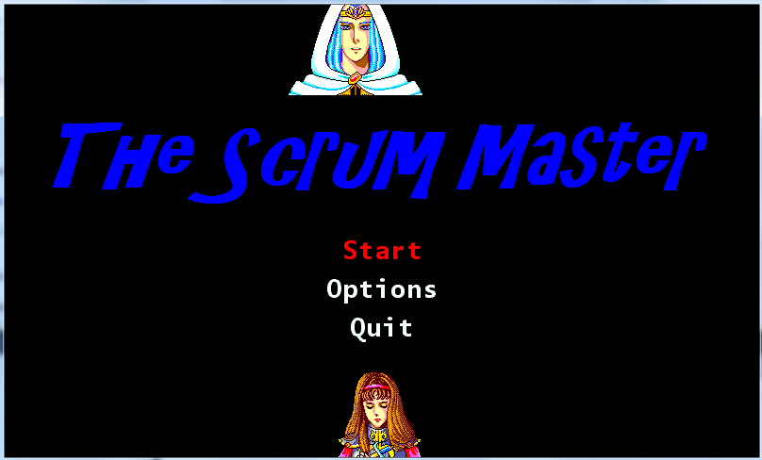

***Start Your Adventure***

Lady Java and her team need to hold a scrum meeting. But all of her team members and perhaps most importantly, the Scrum Master are missing.

Lady Java must investigate throughout her campus to find out where her team members are. She soon learns that finding them will not be at all easy and will involve dangerous missions and unending horror.

***Overworld***

The University Campus is vast and has lots of areas to explore. On campus buildings include a PC repair center, Mini-Mart, Gym, Boat house and many houses. Some natural features include trees and Campus Lake. Make sure you explore everything thoroughly and look for hidden entrances.

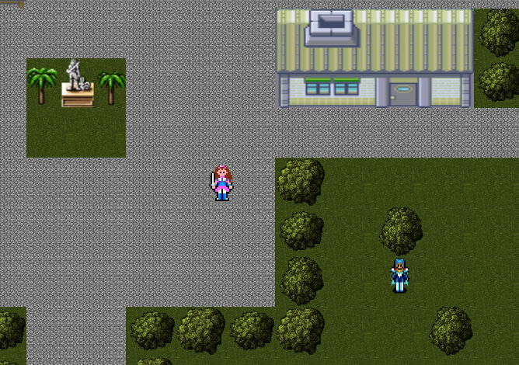

***Students***

When exploring the campus, make sure you speak to all the students in the streets and in buildings. The people on campus will offer useful clues as to where your missing team members are located. Check back with them throughout the game as they might have some new information to share with you.



***Levels***

In order to find your team members you must navigate dungeons. Things look a little different in the dungeons and are much faster paced. You will adjust quickly or be doomed. The dungeons are crawling with enemies and a dungeon boss at the end. Try to find your way to the ‘*Fin’* symbol to beat the dungeon.

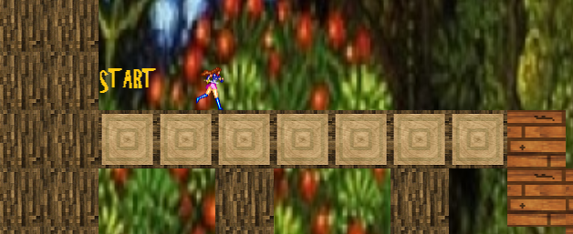

***Enemy***

Enemies move in different patterns and you will need to learn how to handle them. Use your sword to kill enemies, they die with only one hit and can only be found in the dungeons.

***Bosses***

The bosses are similar to enemies but require many strikes of the sword to kill. They move in strange patterns and may take a few tries to kill. Once a boss is defeated you will be able to save your team member.